|  |
| --- |
| **Year 11 Specialist Mathematics**  Semester 1, June 2020  **Test 3: Vector Applications**  **Calculator Free Weighting: 8%**  **[Australian Curriculum Reference Numbers: 1.2.10, 1.2.11, 1.2.12, 1.2.13]** |

**Total Time: 30min Total Marks = $\frac{}{30}$**

**Student Name:**

**Teacher: ___________________________________**

**INSTRUCTIONS TO STUDENTS:**

* You **are not allowed** a calculator or any notes.
* A formula booklet will be provided.

You are required to attempt ALL questions.

Write answers in the spaces provided beneath each question.

Marks are shown with the questions.

**Show all working** clearly, in sufficient detail to allow your answers to be checked readily and for marks to be answered for reasoning. Incorrect answers given without supporting reasoning cannot be allocated any marks. For any question or part question worth more than two marks, valid working or justification is required to receive full marks.

1. Use the vectors $a=\left(-3,4\right) and b=\left(9,-8\right)$ to show that the scalar product is commutative.

|  |
| --- |
|  |
|  |
|  |
|  |
|  |

[3 marks]

1. Two vectors are such that $a=\left[\begin{matrix}4 \\ 0\end{matrix}\right] and b=\left[\begin{matrix}-3 \\ 3\end{matrix}\right].$
   1. Use the scalar product to show that $\cos{(θ)}=-\frac{1}{\sqrt{2}}$, where *θ* is the angle between the vectors.

|  |
| --- |
|  |
|  |
|  |
|  |
|  |
|  |

* 1. Determine the angle between the vectors $a$ and $b$, in radians.

|  |
| --- |
|  |

* 1. Show that the unit vector $j$ is perpendicular to $a$.

|  |
| --- |
|  |
|  |
|  |

[4,1,2 = 7 marks]

1. Determine the vector projection of vector $a$ onto $b$ given that:

$a=\left[\begin{matrix}2 \\ 2\sqrt{3}\end{matrix}\right]$ and $b=\left[\begin{matrix}4\sqrt{3} \\ 4\end{matrix}\right]$.

|  |
| --- |
|  |
|  |
|  |
|  |
|  |
|  |
|  |
|  |
|  |
|  |
|  |

**[7 marks]**

1. Given that $a=2i - 3j , b=4i + 5j and c=2i-j,$ show that $a$ is perpendicular to $\left(b+c\right).$

|  |
| --- |
|  |
|  |
|  |
|  |
|  |
|  |

**[3 marks]**

1. 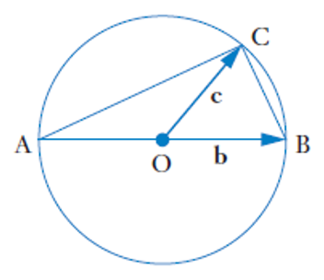The diagram shows a circle with Centre O and diameter $AB$. Point C lies on the circumference. Use the scalar product to prove that:  
     
   “An angle at the circumference subtended by a diameter is a right angle”

|  |
| --- |
|  |
|  |
|  |
|  |
|  |
|  |
|  |
|  |
|  |
|  |
|  |

**[7 marks]**

1. A car going up a hill inclined at 30 $°$ has a weight of $9000 N$ acting vertically downwards.   
   Resolve the weight into components parallel and perpendicular to the slope.

|  |
| --- |
|  |
|  |
|  |
|  |
|  |
|  |
|  |

[3 marks]

**\*\*\* End of Test \*\*\***